 | Labor Day | Monday | September 5, 2022
 | United Way Day of Caring Volunteer Event | Tuesday | September 20, 2022
 | Columbus / Indigenous People Day | Monday | October 10, 2022
 | Veteran’s Day | Friday | November 11, 2022
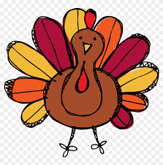 | Thanksgiving Day | Thursday | November 24, 2022
 | Day after Thanksgiving | Friday | November 25, 2022
 | Christmas Break | Friday | December 23, 2022
 | Christmas Break | Monday | December 26, 2022
 | New Years | Monday | January 2, 2023
 | Civil Rights / MLK Jr. Day | Monday | January 16, 2023
 | Teacher Workshop | Friday | March 24,2023
 | Memorial Day | Monday | May 29, 2023
 | Summer Break: Week of Independence Day | Monday | July 3, 2023
 | Summer Break: Week of Independence Day | Tuesday | July 4, 2023
 | Summer Break: Week of Independence Day | Wednesday | July 5, 2023
 | Summer Break: Week of Independence Day | Thursday | July 6, 2023
 | Summer Break: Week of Independence Day | Friday | July 7, 2023

